**How to Configure Email Alerts in Grafana**

we will learn how to configure [email](https://www.fosstechnix.com/how-to-configure-email-alerts-in-grafana/) alerts in [Grafana](https://www.fosstechnix.com/how-to-configure-email-alerts-in-grafana/), a powerful open-source platform used for monitoring and observability. Email alerts are an essential feature of Grafana’s alerting system, providing immediate notification of critical events or anomalies detected in monitored metrics. By setting up email alerts, users can stay informed about important changes in their systems and take proactive measures to address any issues

**Prerequisites**

* AWS Account with Ubuntu 22.04 LTS EC2 Instance.
* Basic knowledge of AWS services, Prometheus and Grafana.

**Step #1:Configure SMTP Settings**

To enable email alerts, Grafana requires SMTP (Simple Mail Transfer Protocol) configuration. SMTP settings specify the email server through which Grafana will send alert notifications.

So first we need to retrieve the password to give in smtp configuration.

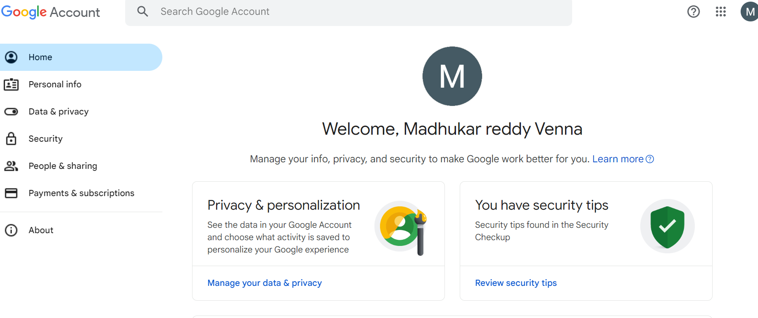

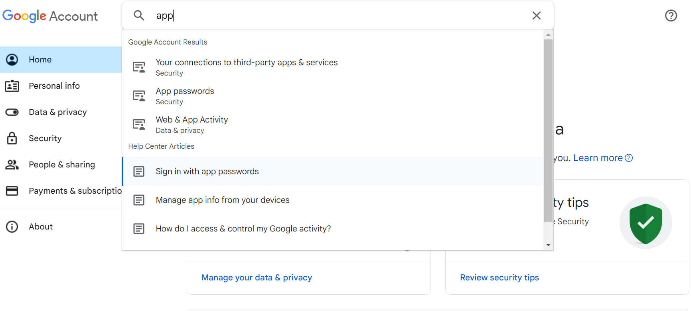

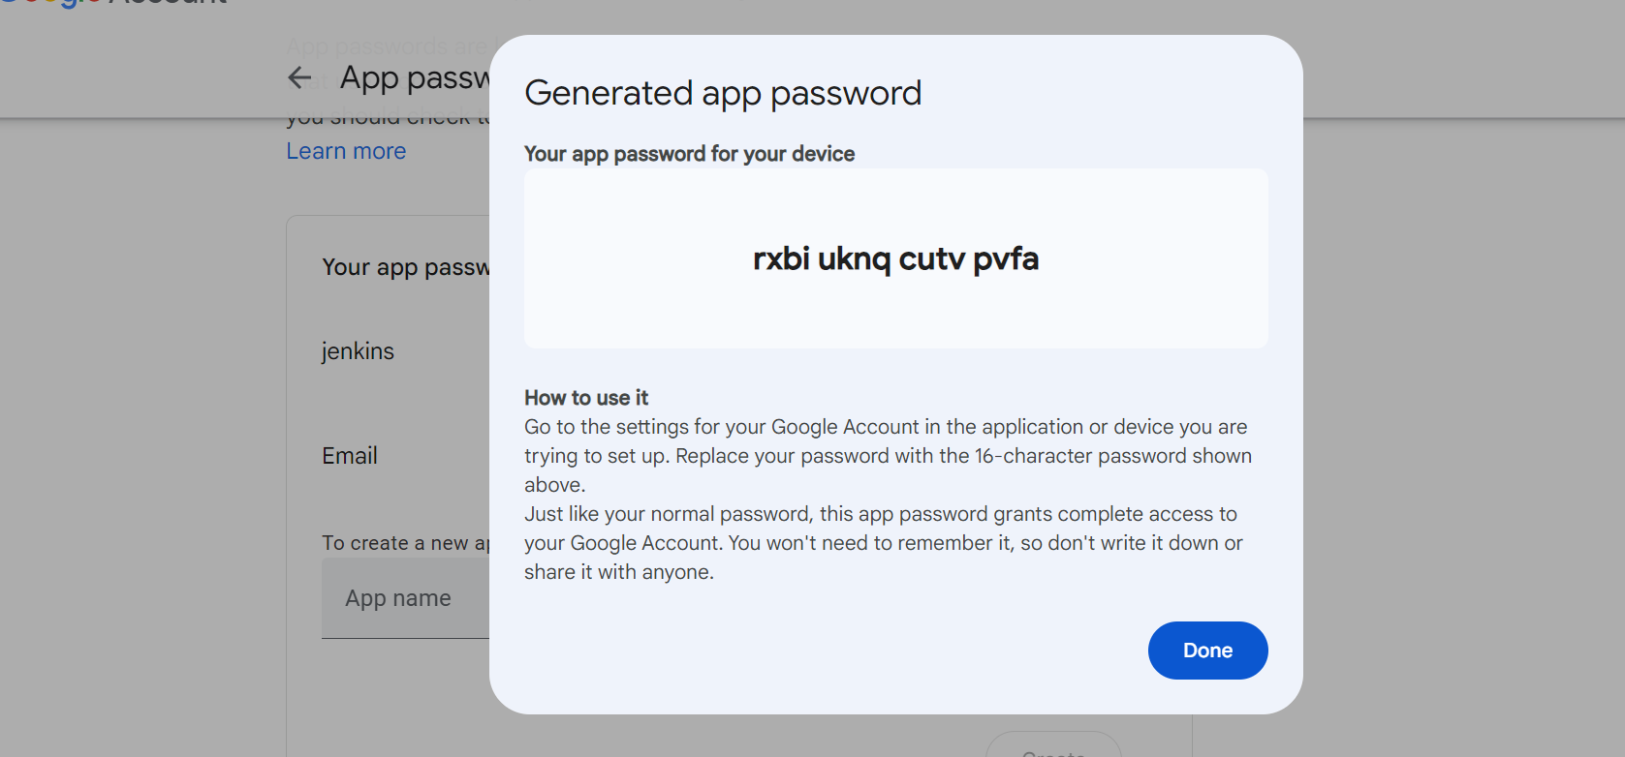

now open **/etc/grafana/grafana.ini** file

sudo nano /etc/grafana/grafana.ini

edit it as shown below.

[smtp]

enabled = true

host = smtp.gmail.com:587

user = vmrreddy912@gmail.com

password = your app password

skip_verify = true

from_address = vmrreddy912@gmail.com

from_name = Grafana

save it and restart the grafana server.

sudo systemctl restart grafana-server

**Step #2:Add Prometheus as a data source in Grafana**

Now go to the Grafana welcome page. Go to the Home in the left top corner.

Then go to the Connections and select the Data sources option.

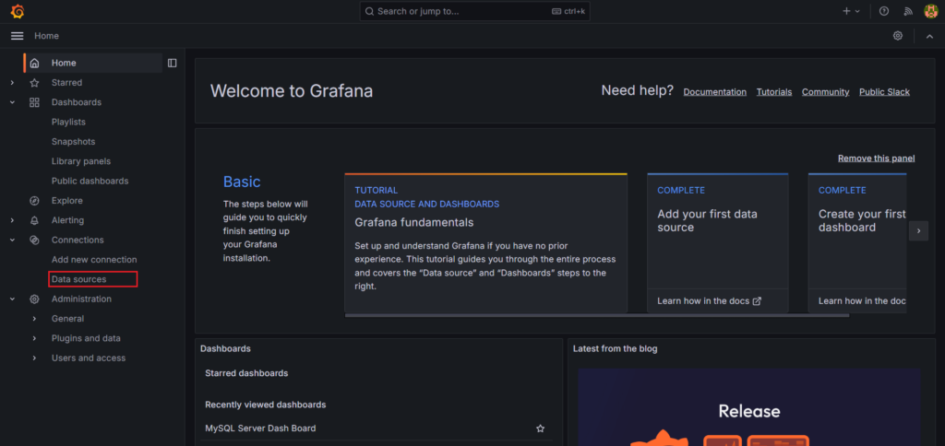

Click on Add Data Source

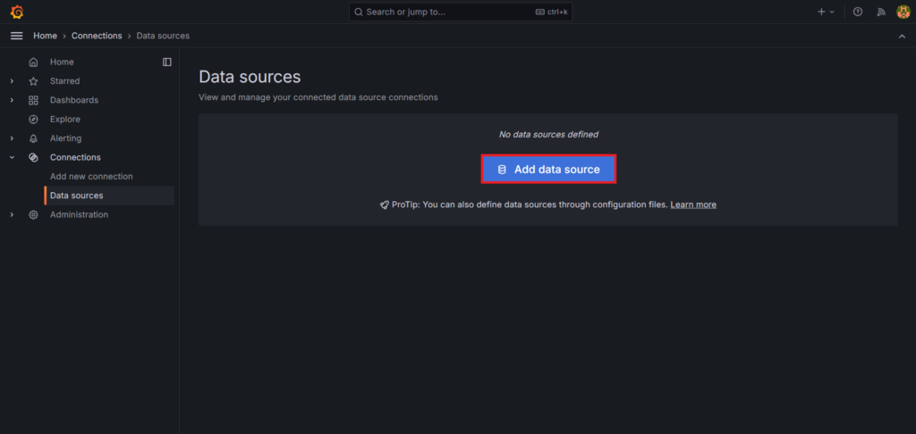

Search for Prometheus in the search bar and select it.

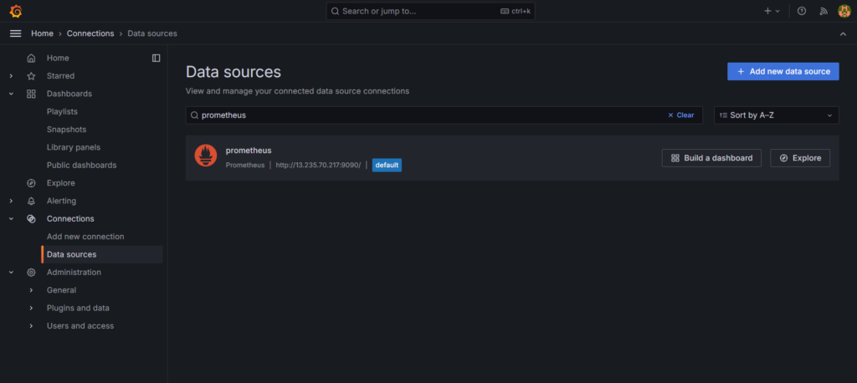

In connection, in Prometheus server URL, give the server url on which our [prometheus](https://www.fosstechnix.com/how-to-configure-email-alerts-in-grafana/) is running.

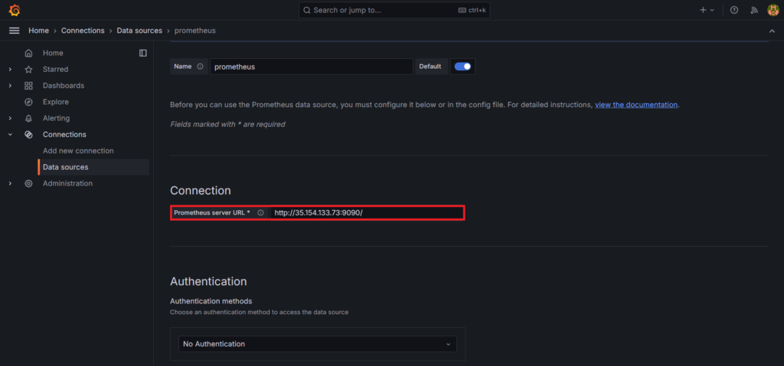

after this click on save and test button. You will see the message for prometheus being successfully queried.

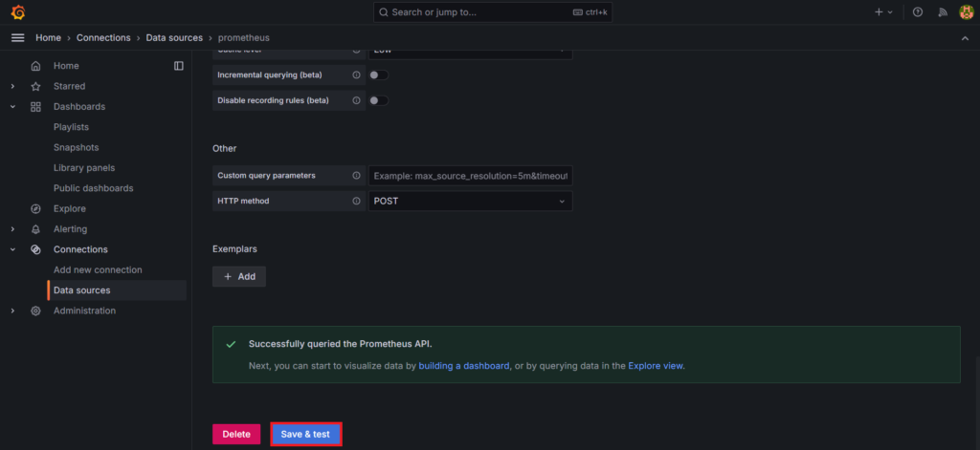

**Step #3:Add a Contact points**

Get back to the [Grafana](https://www.fosstechnix.com/how-to-configure-email-alerts-in-grafana/) home page and select the Alerting > Contact points.

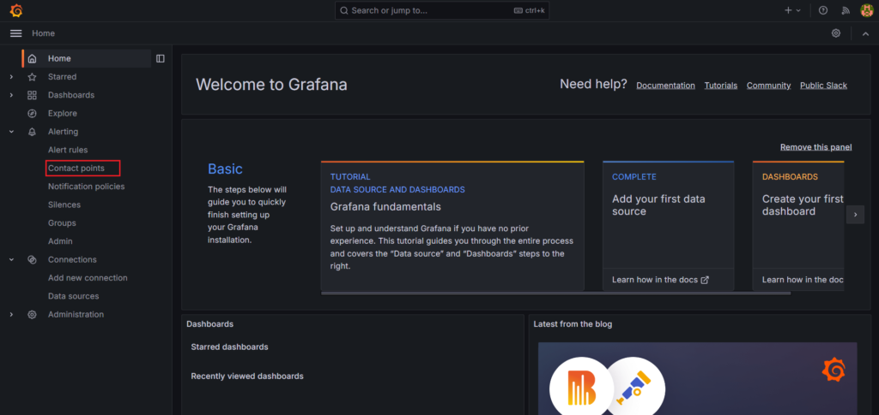

click on Add contact point.

Give a appropriate name to your contact point. Like Grafana.

Select Email as a Integration

Then in addresses give the email id or id’s with comma separating them.

And click on Test to test it.